1. **COMPONENTS LIST AND CONNECTION BLOCK DIAGRAM w/ PINS**

* Xplained Mini
* LED
* Wire

1. **INITIAL/MODIFIED/DEVELOPED CODE OF TASK 1/A**

Assembly Code:

.ORG 0;location for reset

JMP Lets_Begin

.ORG 0x02;location for external interrupt 0

JMP EX0_ISR ; jumps to interrupt label

Lets_Begin:

LDI R20,HIGH(RAMEND)

OUT SPH,R20; initialize upper stack

LDI R20,LOW(RAMEND)

OUT SPL,R20; initialize lower stack

LDI R20,0x02;make INT0 falling edge triggered

STS EICRA,R20

SBI DDRB,2;PORTB.2 = output

SBI PORTD,2;pull-up activated

LDI R20,1<<INT0;enable INT0

OUT EIMSK,R20

SEI;enable interrupts

LETS_WAIT:

JMP LETS_WAIT

EX0_ISR:

IN R21,PORTB ; readas PORTB

;;;;;;;;;;;;;;;;;; Toggles The LED;;;;;;;;;;;;;;;;;;;;;;;;;;;;;;;;;;;

LDI R22,(1<<2)|(1<<5) ;

EOR R21,R22

OUT PORTB,R21

;;;;;;;;;;;;;;;;;;;;;;;;;;;;;;;;;;;;;;;;;;;;;;;;;;;;;;;;;;;;;;;;;;;;;

rcall Delay; will go to subroutine

;;;;;;;;;;;;;;;;;; Toggles The LED;;;;;;;;;;;;;;;;;;;;;;;;;;;;;;;;;;;

LDI R22,(1<<2)|(1<<5)

EOR R21,R22

OUT PORTB,R21

;;;;;;;;;;;;;;;;;;;;;;;;;;;;;;;;;;;;;;;;;;;;;;;;;;;;;;;;;;;;;;;;;;;;;

RETI

;;;;;;;;;;; will delay the duration of the LED being on ;;;;;;;;;;;;;

Delay:

ldi r20, 123

nop

nop

nop

nop

nop

D1:

ldi r21, 250

nop

nop

nop

D2:

ldi r22, 107

nop

nop

Del_LP:

nop

nop

nop

dec r22

brne Del_lp

nop

nop

dec r21

brne D2

nop

dec r20

brne D1

ret

;;;;;;;;;;;;;;;;;;;;;;;;;;;;;;;;;;;;;;;;;;;;;;;;;;;;;;;;;;;;;;;;;;;;;

1. **DEVELOPED MODIFIED CODE OF TASK 2/A from TASK 1/A**

C code:

#define *F_CPU* 16000000UL

#include <avr/io.h>

#include <avr/interrupt.h>

#include <util/delay.h>

int main ()

{

DDRB |= (1<<2)|(1<<5);//PB5 as an output

PORTB |= (1<<2)|(1<<5);

PORTD = (1<<2);//pull-up activated

EICRA = 0x2;//make INT0 falling edge triggered

EIMSK = (1<<INT0);//enable external interrupt 0

sei ();//enable interrupts

while (1);//wait here

}

ISR (INT0_vect)//ISR for external interrupt 0

{

PORTB ^= (1<<2);//toggle PORTB.2

*_delay_ms*(1250);

PORTB ^= (1<<2);//toggle PORTB.2

}

1. **SCHEMATICS**

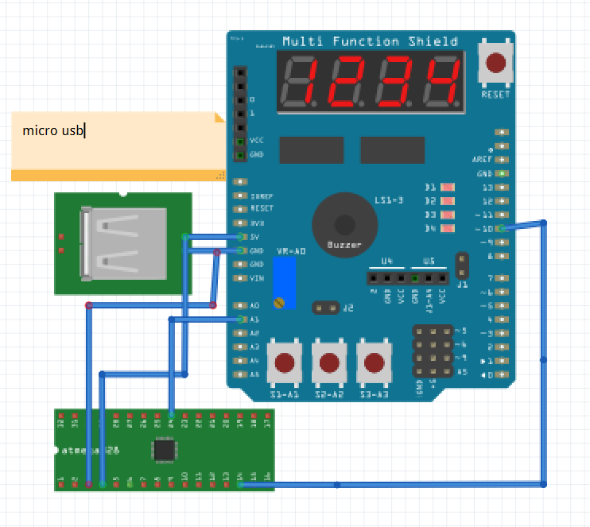

1. **SCREENSHOTS OF EACH TASK OUTPUT (ATMEL STUDIO OUTPUT)**

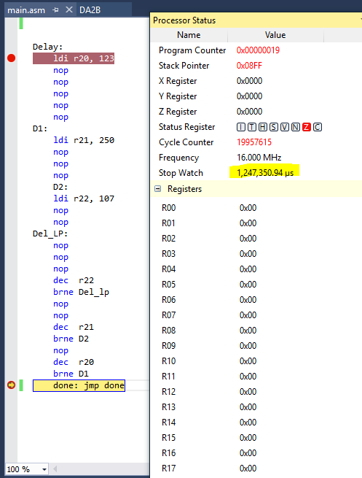

1. **SCREENSHOT OF EACH DEMO (BOARD SETUP)**

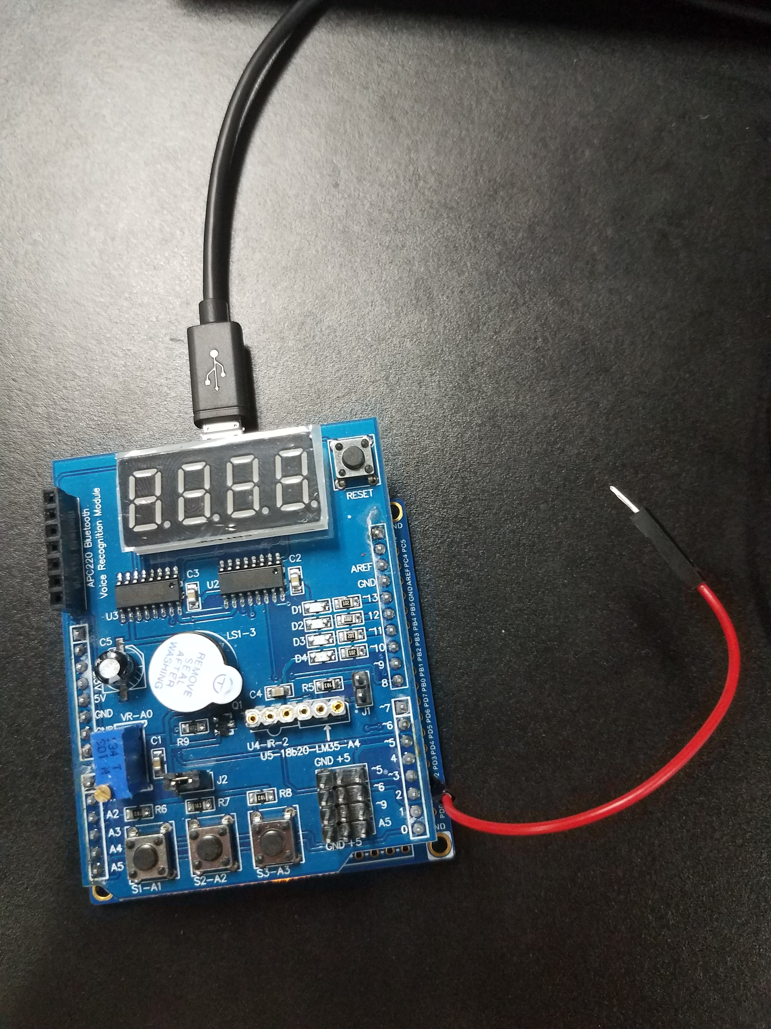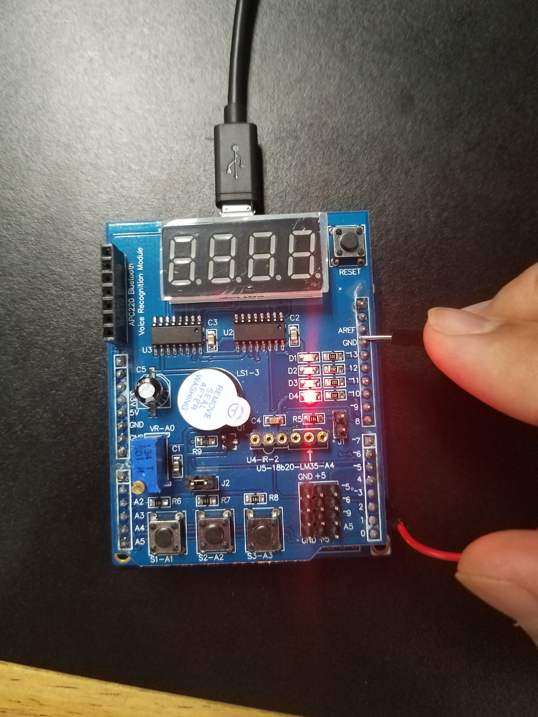

1. **VIDEO LINKS OF EACH DEMO**

Assembly:

<https://www.youtube.com/watch?v=50V4eyY7t-Q>

C Code:

<https://www.youtube.com/watch?v=PeBGi8ci9j8>

1. **GITHUB LINK OF THIS DA**

<https://github.com/RickyPerez79/submission_da>

**Student Academic Misconduct Policy**

<http://studentconduct.unlv.edu/misconduct/policy.html>

“This assignment submission is my own, original work”.

RICKY PEREZ